Step 1: Push the (+) plus sign in the top left corner that will give you a window where you set all your options give it a name and in the Runner Drop Down menu select what you want to do (Wine) for Windows Games
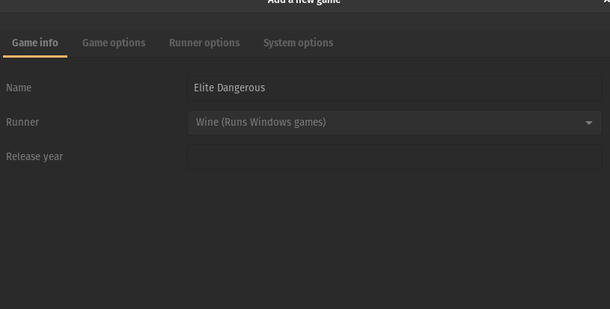
Step 2: Configure your Game Options In the Executable field browse for the games EXE file, that launches the game.

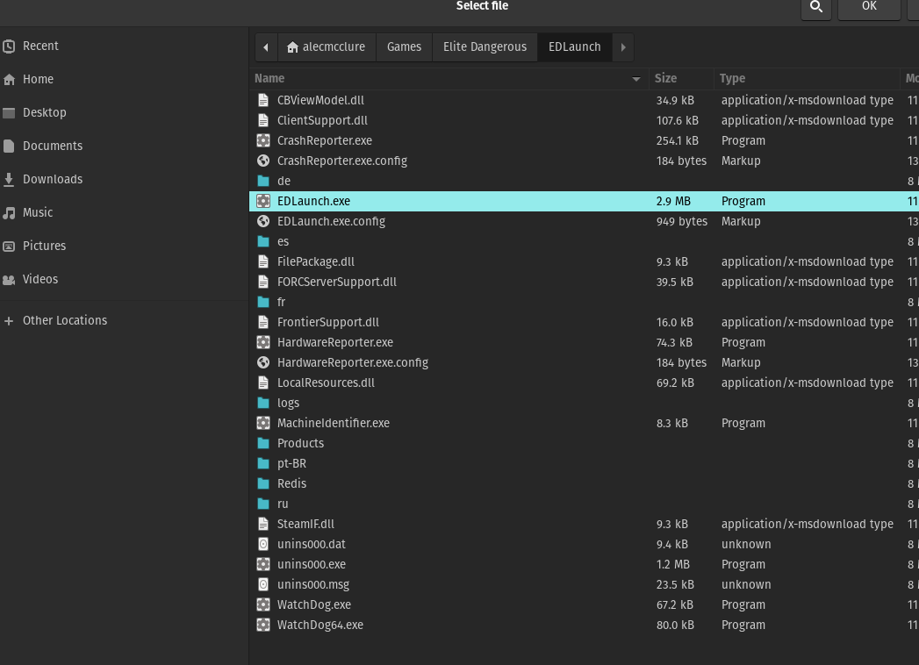
Step 3: Create a folder to store Wine Settings Here I created a new folder and named it the Games name.

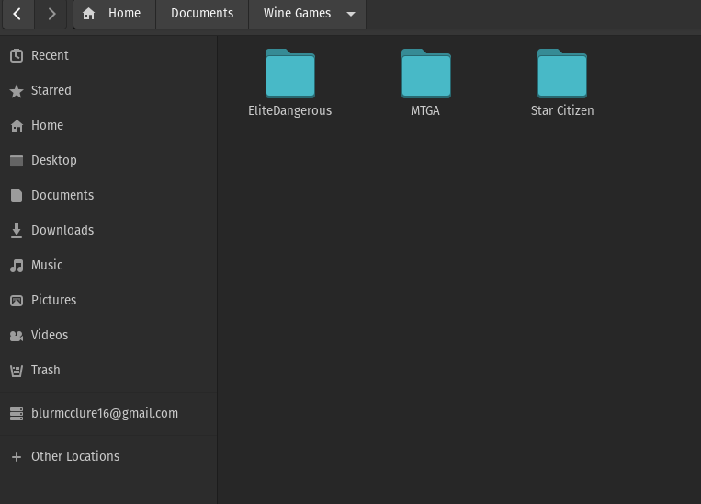
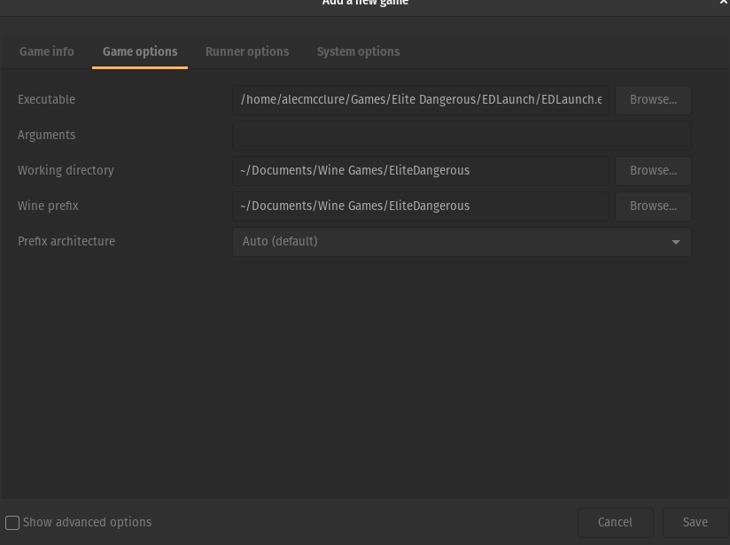
Step 4: Select that new empty folder for both the working directory and wine prefix.

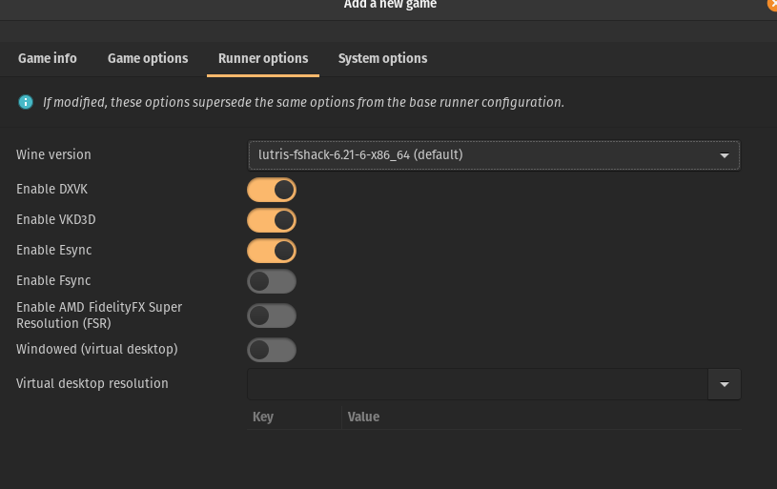
Step 5: Configure Runner Options: I typically leave this default, but this is where you can play with settings to get things working.

Step 6: Configure System Options, You should be able to leave this default but I like to store all my Wine games in a separate folder.
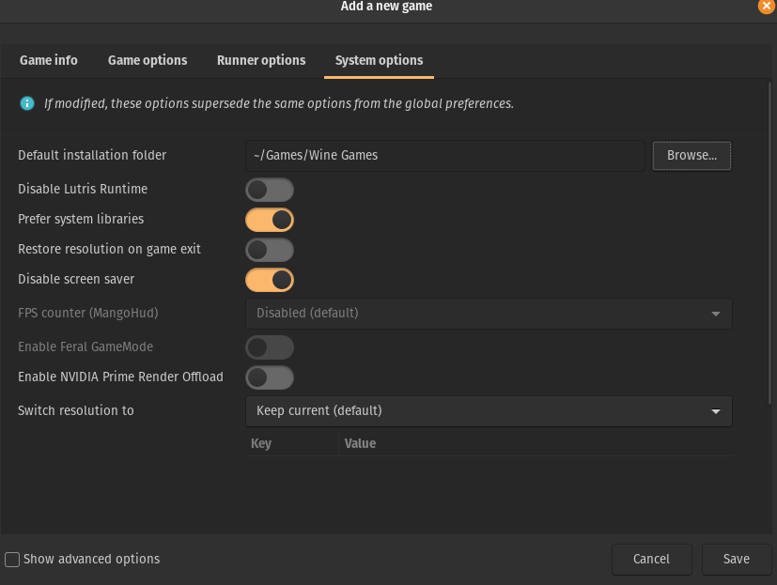

Step 7: Click Save and you should now have a new game in your library that you can launch. You may get some install boxes to install things like Visual C++ but that is expected as the game is now launching in a Wine Environment.
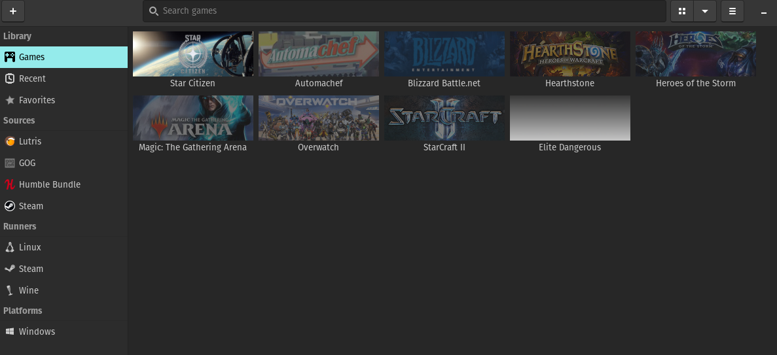
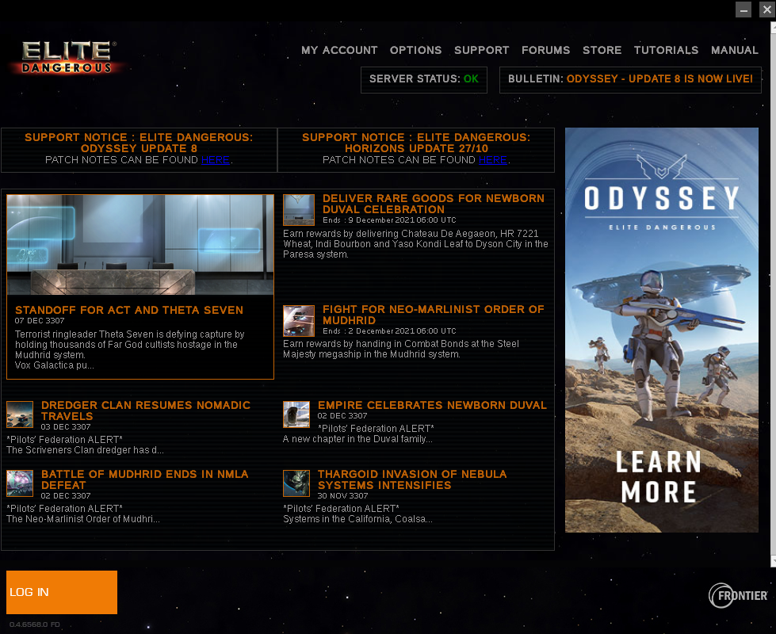
Step 8: After going through all the install prompts eventually your game should Launch. If it doesn’t you can try to play around with different options in your Runner Options tab for the game.

